Data Visualisation CA1

Business Style Magazine.

Name: Bijayendra Lama
Student Number: 17154201

MSc in Data Analytics
21st February 2019

Agriculture, its effects and implications.

Introduction:

Agriculture is the science of producing food products by either the usage of plants or livestock using different techniques.Agriculture is growing at a massive scale in response to growth in population, health, demand and development, also in relation to financial income. Modern agriculture extends beyond a traditional reason to eat and survive.
It has its effects and relationship with respect to many other factors such as growth, GDP, health, emissions and employment.
This article aims at showing trends and what we understand at current regarding the implications of
Agriculture.
Data used is World Development Indicators extracted from World Bank http://www.worldbank.org/
and is the latest yearly data updated on 01/30/2019.

Content:

Tropical Deforestation in Sub-Saharan Africa has been owned to growing populations, changes in settlement patterns, growing demands for food and clearing of forests for growing tropical foods such as cassava and yams.High deforestation rates from 2000 to 2005 has led to larger areas of land unsuitable for Agriculture. (Rudel,2013)

Russia has the highest available agricultural area as well as it has the maximum forest coverage as compared to other countries.Countries such as Greenland and United Arab Emirates as struggling in terms of both areas which could probably be because of climatic conditions.
Growth of agricultural lands often leads to deforestation and has been increasing owing to the ever increasing population and demand for food.
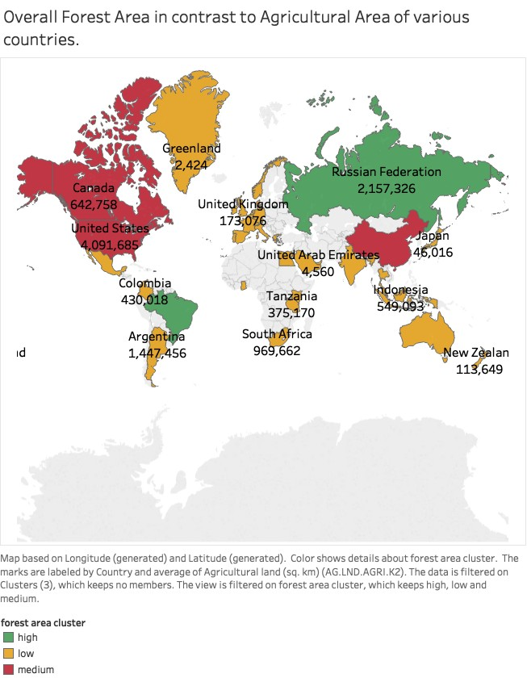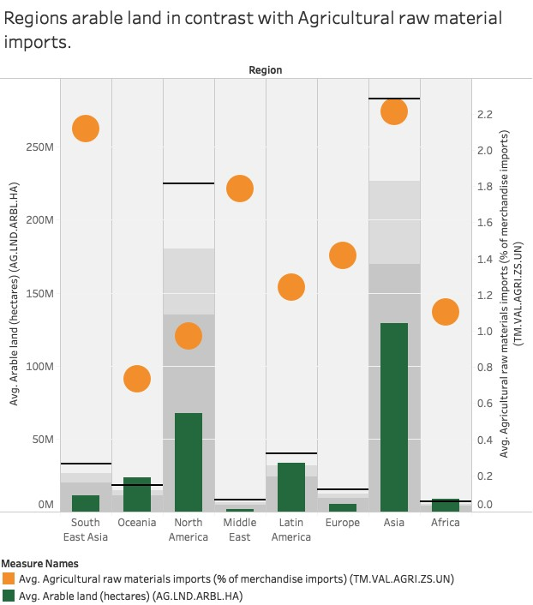Asia has the largest areas for food cultivation whereas Europe and the middle east has the smallest area, and most of the regions also have a healthy import of agricultural raw materials owing to international trade and business.

All these demand for food can have serious consequences on the environment.A study on tropical forests shows that agriculture is the major reason behind deforestation
in these regions.Despite the important uses of forests, the rate of forest loss has been on the increase over the past 3 to 5 decades.

The Food and Agriculture Organization (FAO) in 2001 has estimated that 450 million hectares of tropical forest was lost between
1960 and 1990.Africa has the highest rate of forest loss and statistic have shown that Africa could loose its entire forest area in the next 150 years and South America in the next 250 years.The picture on the left clearly shows that
Africa already has very low regions of forest cover and it could all disappear sooner than anticipated.(Benhin et al,2006)

Excessive demand has led to growing imports of Agricultural Raw Materials.
Forest depletion has serious effects on crop yield and the soil loses its natural fertility. To replenish this countries are heavily utilising fertilisers which in turn effect the climate and health of individuals who consume the grown food.

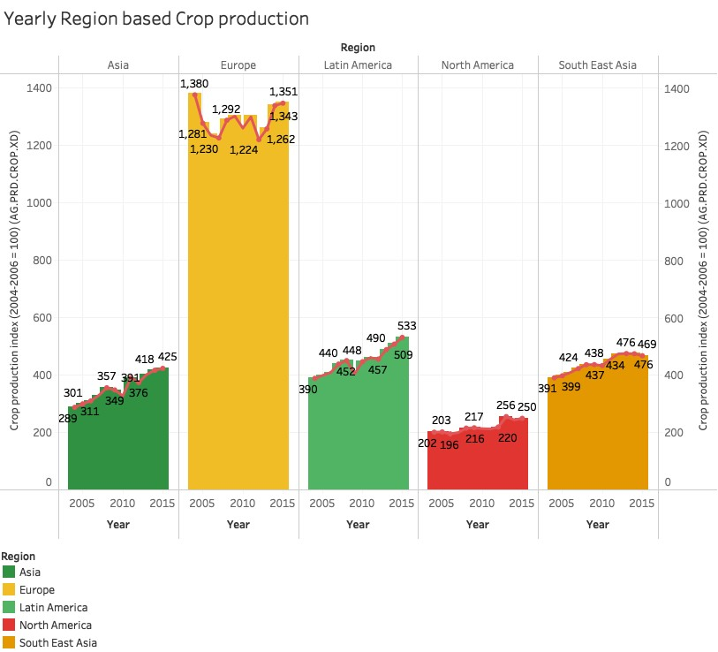Crop production index shows the production in relation to the base period and it includes most of the crops.Europe tops the charts in this matter and has it seems to have some yearly fluctuations but it is still doing well compared to the rest of the regions.North America is the lowest in this category owing to its climatic conditions.

If we contrast food export and the crop production index of all the regions we can see a relation and both seem to follow a similar trend and correlation.

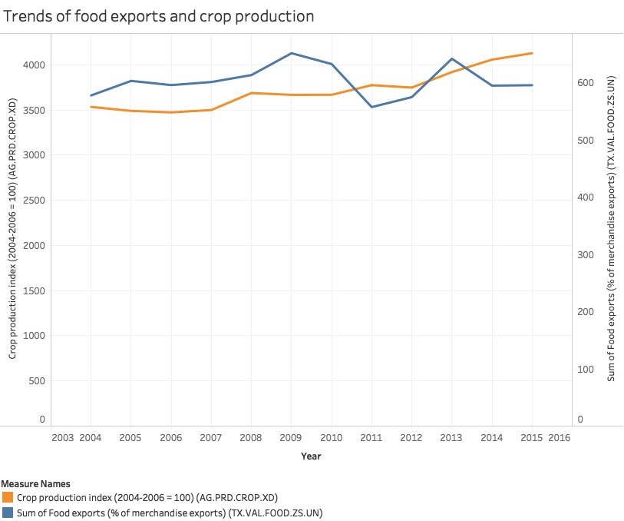

North America has the highest GDP owing to other factors however for the other region we can suggest that there is a relationship between GDP and cultivation lands these regions have.

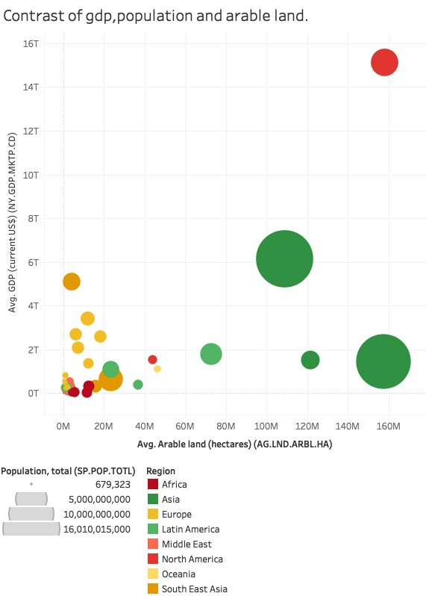It also has effects on employment and requirement to import food due to unavailability of certain food products.

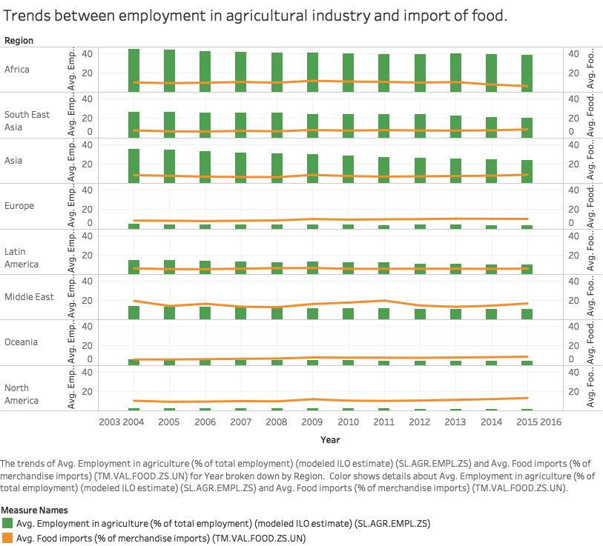
In the United States agriculture is responsible for 7% of the total emissions of green house gases into the atmosphere. Cutting these emissions can help air and water quality in a number of ways.Some practices can reduce runoff of nitrogen and phosphorus that are essential for development of aquatic plants and In an extreme case of the Gulf of Mexico these compounds were carried by a river and have created seasonal dead zones.(Parton,et al,ND)

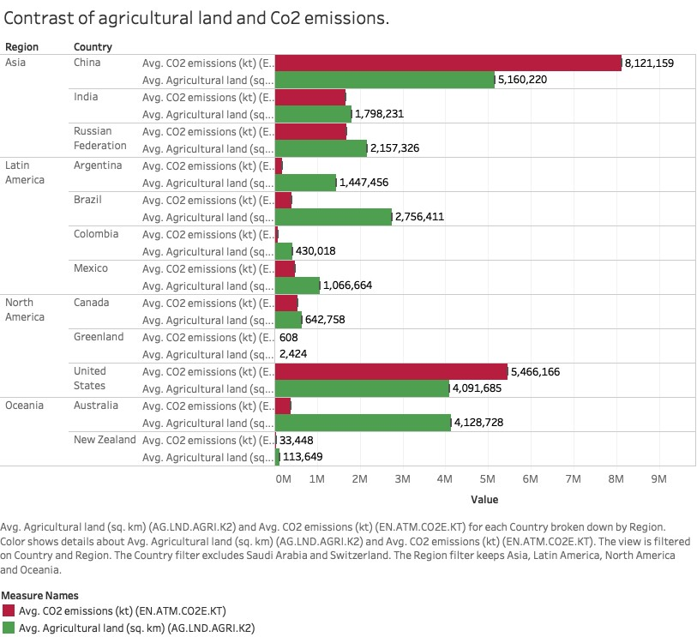Studies have shown that Chinas agricultural carbon emission.T carbon emissions for agriculture in west increase rapidly. The area differentiation of Carbon Emissions for agriculture in China decreases. Industrial structure energy efficiency and labor transfer has had significant effects on agricultural carbon emissions performance. (Li,2013)

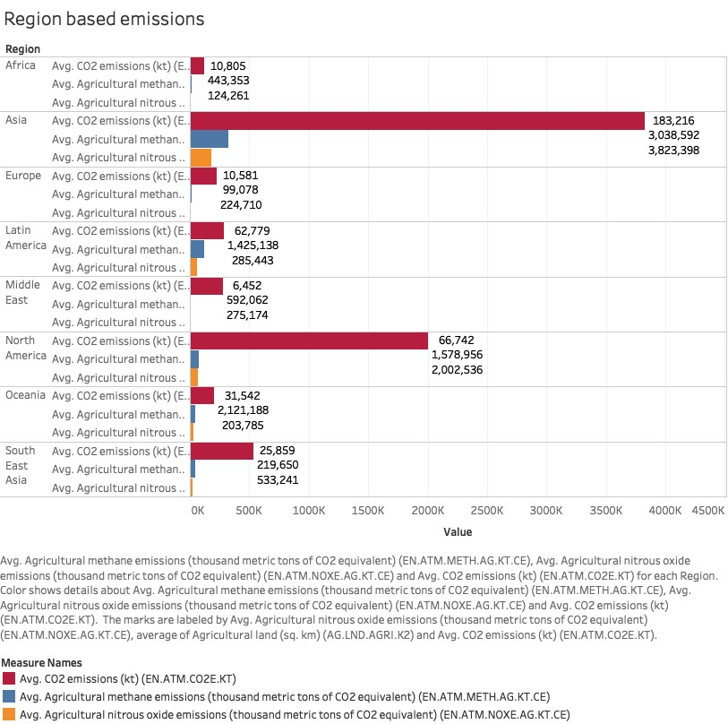

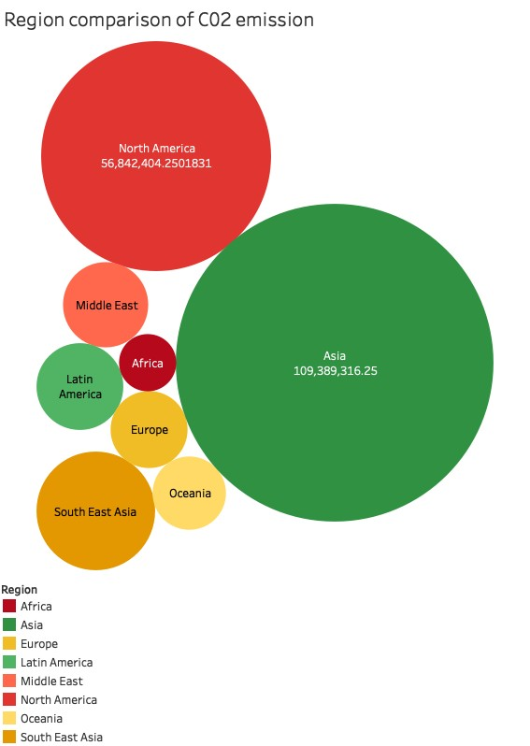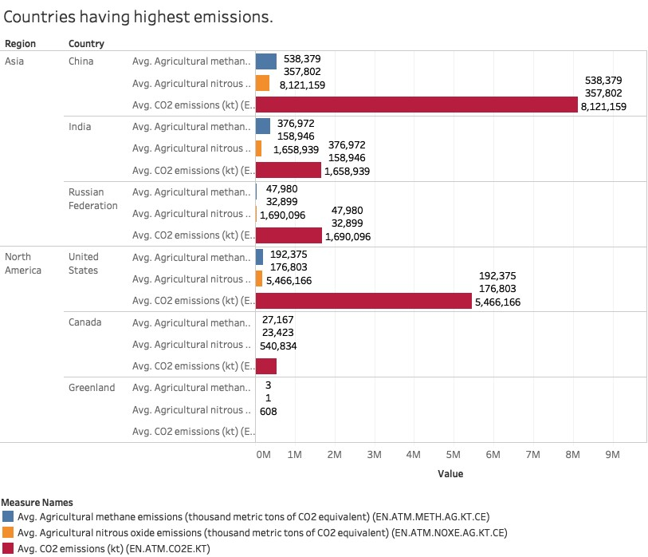

Changes in agricultural management to improve crop yield and land productivity has led to significant implications for emissions.Most of the carbon emission attributed to change in land use and cover, and changes in atmospheric carbon dioxide.(West and Maryland,2003).
Rising wages in this sector has created employment but has risen to the point where farmers are no longer able to profit from their produce. (Rudel,2013).Agriculture is the main source of income for majority of the farmers in developing countries such as India and African nations.India and China
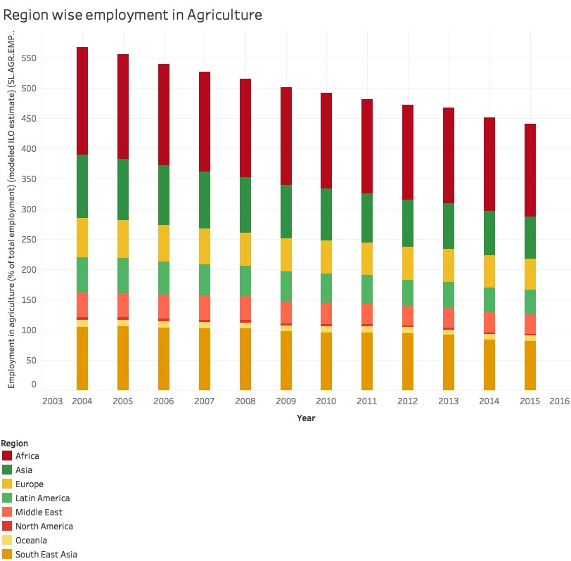are however the leading producer of food products in the world.
Due to continuing rise of agricultural emissions and increase of particulate matters there has been a rise in the cases of tuberculosis and other respiratory diseases.Asia has the highest reported cases of tuberculosis which directly related to the carbon dioxide emissions.The capital of India ,New Delhi has huge quantities of particulate matter owing to burning of crop yields and waste.This procedure
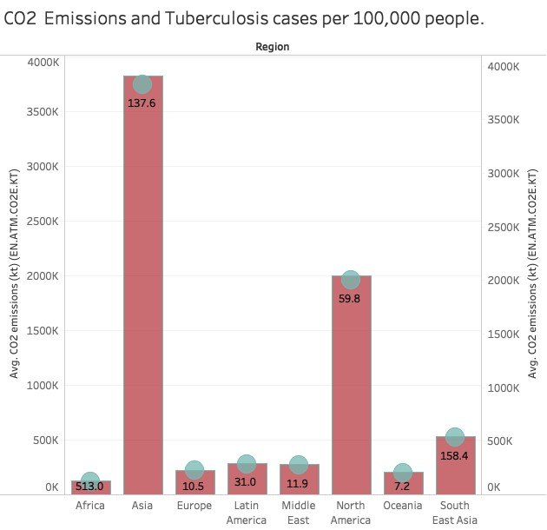is employed as an easy substitute of properly disposing the left over yield and the results have been increasing cases of diseases such as Asthma and Tuberculosis.

The PM 2.5 air pollution rating shows the middle eastern regions lead followed by Asia which also suggests effects of emissions from Agriculture.

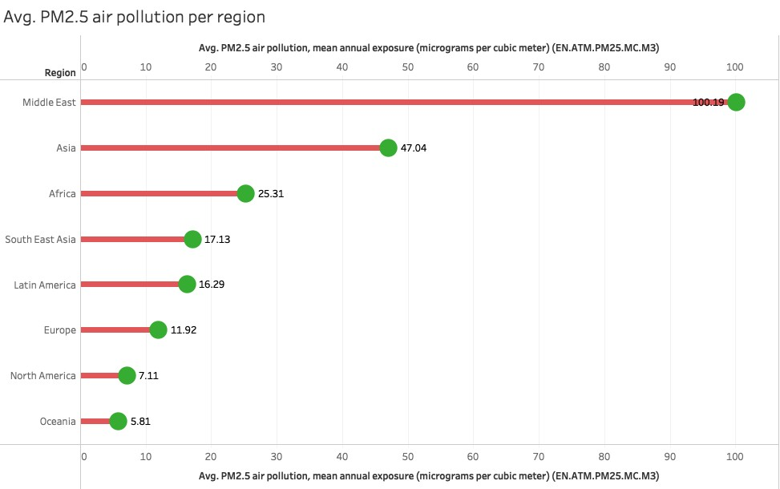

Main source of green house gases from agriculture is from the emission of nitrous oxide from soils treated with nitrogen based fertilisers.Methane is also another influential source owing to cattle. Soil and Nitrous oxide is deemed to be responsible for at least two thirds of all agricultural green- house gas emissions. Nitrous oxide has a heat trapping effect that is almost 310 times greater than that of carbon dioxide. Fertilisers based on new technologies are designed to give a gradual supply of nitrogen into the soil.(Parton,et al,ND)

Research shows that stabilised fertilisers produce good yields with lesser emissions of gases.Using these fertilisers in western regions of the United States has resulted in a 60% reduction in N2O emissions for irrigated crops and a 30% reduction for non-irrigated crops. However, the use of these fertilisers in central and eastern regions of the country has shown inconsistent effects.(Parton,et al,ND)

Africa has the highest consumptions for fertiliser followed by Asia.Fertilisers have a rather harmful affect on health. The toxic chemicals found in fertilisers get absorbed by plants and also flow into ground water. Once absorbed, these chemicals enter the food chain and pose a high risk of health issues. (lettucegroup, 2018)

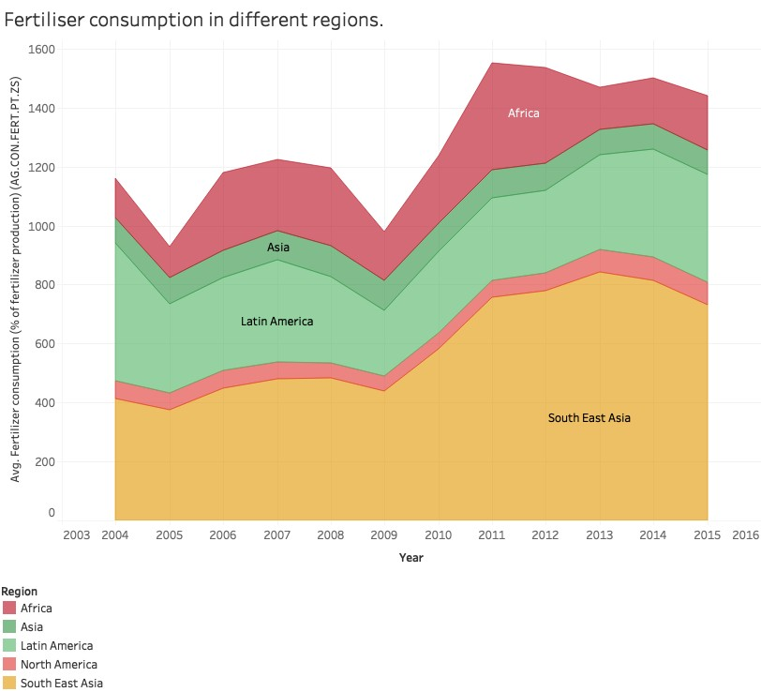

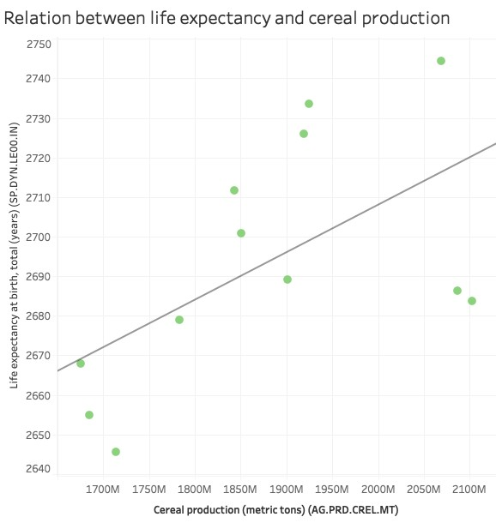

The main reasons agriculture is used for is to provide a healthy supply of food and feeding populations.New technologies and practices can be adopted to change the way agriculture is effecting the world in a bad way. Our report shows that cereal production is directly related to life expectancy.
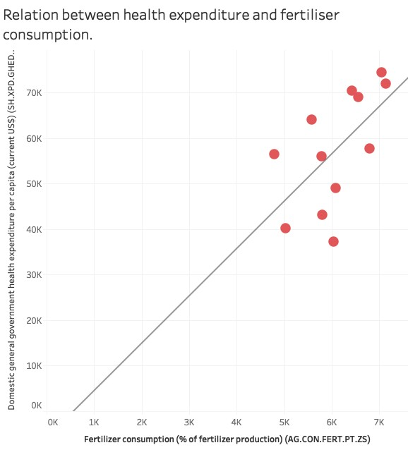

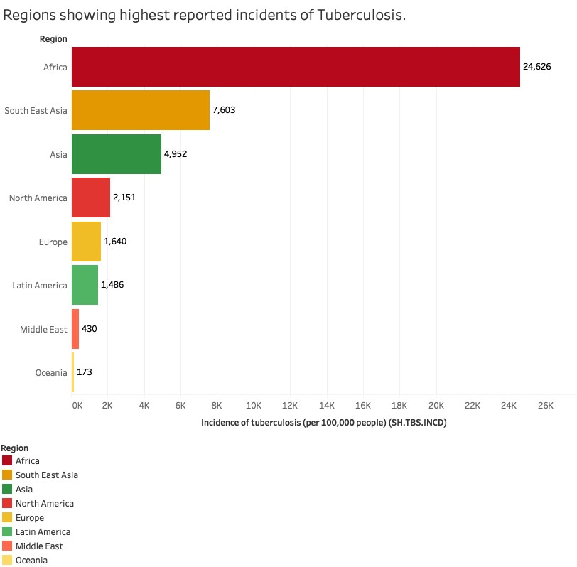

Africa shows the highest reports of tuberculosis followed by Asia.According to research, there is positive relationship between air quality and tuberculosis. A research conducted by Smith (2017), positive associations were found with ambient Carbon dioxide and Nitrous Oxide release, which suggest that increase in these levels can have an affect on tuberculosis.
Conclusion :

The world needs to reconsider its management practices when it comes to Agriculture to reduce the ill effects in terms of climate change, green house gas emissions , employment.
Studies and research have shown that there are available techniques to overcome deforestation and
References:

(Rudel Thomas).2013.’The national determinants of deforestation in sub-Saharan Africa’.The royal society publishing.

(West and Maryland),2003.’
Net carbon flux from agriculture: Carbon emissions, carbon sequestration, crop yield, and land-use change’.Kluwer Academic Publishers.

(Parton,et al).ND.’Agriculture’s Role in Cutting Greenhouse Gas Emissions’.Issues in Science & Technology.University of Texas.

(Benhin et al,2006),2003.’Agriculture and Deforestation in the Tropics: A Critical Theoretical and
Empirical Review’.Alliance Communications Group, A Division of Allen Press, Inc. Feb 2006.

(Li Pang,2013).Influential factors and area differentiation of carbon emissions for agriculture in
China.IEEE Explore.2013.

Smith, G. S., Van Den Eeden, S. K., Garcia, C., Shan, J., Baxter, R., Herring, A. H., Richardson, D. B., Van Rie, A., Emch, M., … Gammon, M. D. (2016). Air Pollution and Pulmonary Tuberculosis:
A Nested Case-Control Study among Members of a Northern California Health Plan. Environmental health perspectives, 124(6), 761-8

Lettucegroup (2018), How do fertilisers aﬀect human health . Available at : https://
lettucegroup4.weebly.com/eﬀects-on-human-health.html

